IRCTC

1. IRCTC

Entities : Train, Ticket, Customer
Tickets can be reserved or unreserved.
Each reserved ticket must correspond to a train and a customer.
Each unreserved ticket must correspond to a customer.
A customer cannot be in two trains at the same time.

1. Train (Strong Entity)
- Each train has a unique train number.
- Attributes: train_id, train_name, source, destination, departure_time, arrival_time.

2. Customer (Strong Entity)
- Each customer has a unique customer ID.
- Attributes: customer_id, name, email, phone.

3. Ticket (Weak Entity)
- Ticket depends on Customer (and optionally Train if reserved).
- Attributes: ticket_id, type (reserved/unreserved), booking_date, seat_number (nullable if unreserved).
- Relationship:
  - Reserved Ticket ⟶ linked to both Customer and Train
  - Unreserved Ticket ⟶ linked only to Customer

Relationships

1. Books (Customer ↔ Ticket)
- One customer can book many tickets.
- Each ticket belongs to exactly one customer.

2. Assigned_To (Ticket ↔ Train)
- Only reserved tickets are assigned to trains.
- Unreserved tickets do not need this relationship.

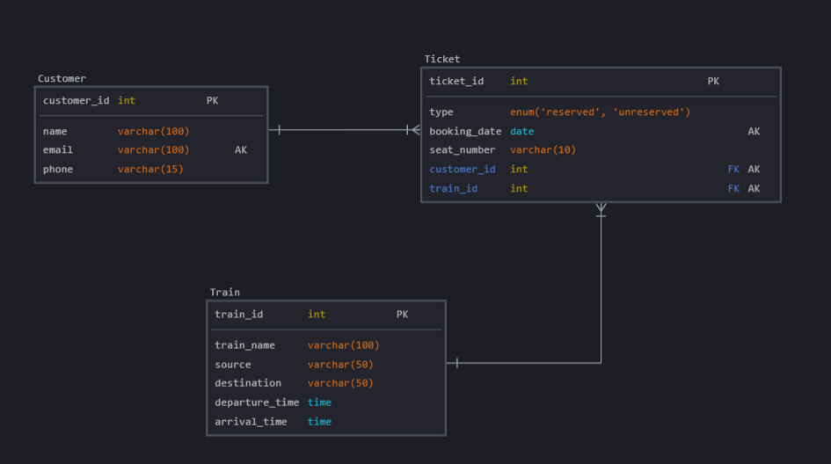

Hotel Booking

2. Hotel Booking

Entities : Hotel, Customer
Customers can be first time users or loyal customers.
Customers can book from only one hotel at a time. A hotel can have many customers.

1. Hotel – Strong Entity
- Each hotel is uniquely identified.
- Attributes: inn_id, inn_name, location, rating.

2. Guest (for Customer) – Strong Entity
- Each customer is uniquely identified.
- Type: first-time user / loyal customer.
- Attributes: guest_id, name, email, phone, guest_type.

3. Booking – Weak Entity
- Represents a booking done by a guest at a specific inn.
- A guest can have only one active booking at a time.
- Attributes: booking_id, guest_id, inn_id, check_in, check_out, room_type.

Relationships
- A Guest can make multiple Bookings, but only one active booking at a time.
- A Booking must be associated with exactly one Inn.
- An Inn can serve multiple Guests.

Hotel_Booking ER- Diagram

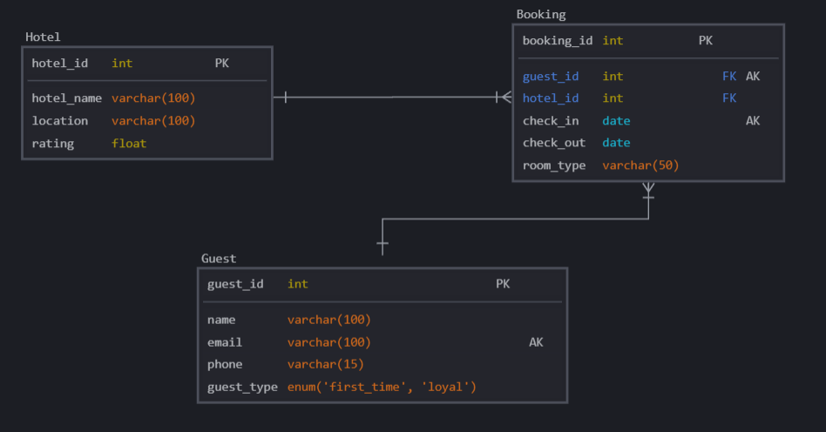

E-Commerce

3. E-Commerce

Entities : Supplier, Customer, Items, Order
Every item should correspond to a supplier.
One supplier can have more than one item.
A customer can have one order at the same time.
One order can have multiple items from multiple brands.

1. Vendor – Strong Entity
- Supplies products sold on the platform.
- Attributes: vendor_id, vendor_name, contact_email, location.

2. Shopper – Strong Entity
- Make purchases on the app.
- Attributes: shopper_id, name, email, phone.

3. Product – Strong Entity
- Must be associated with one Vendor.
- Attributes: product_id, product_name, price, stock, category, vendor_id.

4. Purchase – Weak Entity
- Represents an order made by a Shopper.
- A shopper can only have one active order at a time.
- Attributes: purchase_id, shopper_id, order_date, status.

5. PurchaseItem (Weak Entity)
- Captures multiple items per order (many-to-many between Purchase and Product).
- Attributes: purchase_id, product_id, quantity.

E-Commerce E-R Diagram
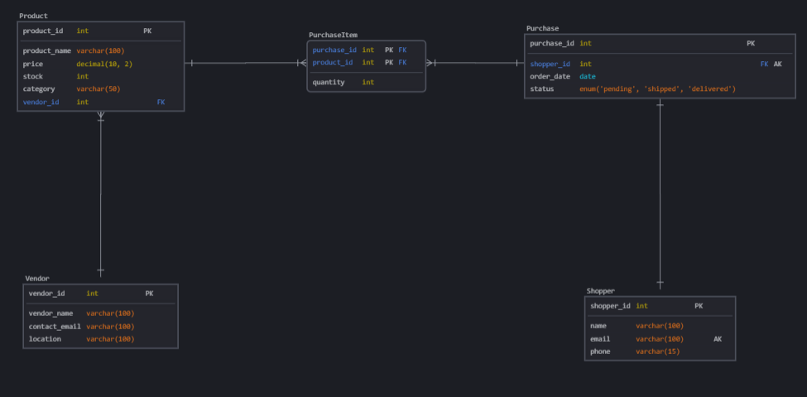

IMBD

4. IMBD

Entities : Movie, Actors, TV series
A TV series or a movie must have an actor. An actor can act in both.

1. Actor – Strong Entity
- Attributes: actor_id, name, birthdate, gender, nationality.

2. Movie – Strong Entity
- Attributes: movie_id, title, release_year, genre, duration.

3. TVSeries – Strong Entity
- Attributes: series_id, title, start_year, end_year, genre, num_seasons.

4. ActsInMovie – Weak Entity

- Links actors to movies (many-to-many).
- Attributes: actor_id, movie_id, role.

5. ActsInSeries – Associative Entity
- Links actors to TV series (many-to-many).
- Attributes: actor_id, series_id, role.

IMBD ER-Diagram
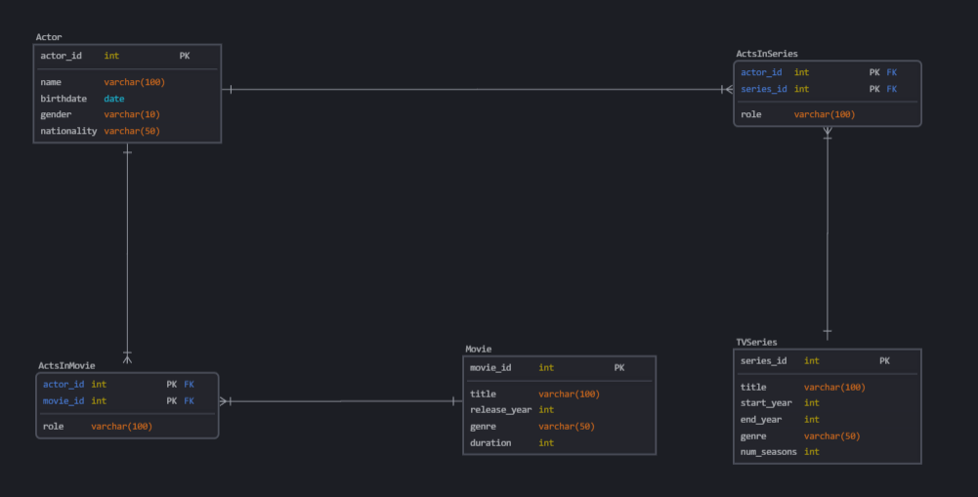

Paytm

5. Paytm
Entities : Accounts, Customer, Branches.
Each customer must have an account. Joint accounts are allowed.
A customer can have multiple accounts in different branches, but not in the same branch.
A branch can have many accounts.

1. Customer – Strong Entity
- A person who owns one or more accounts.
- Attributes: customer_id, name, email, phone, address.

2. Branch – Strong Entity
- A physical bank location.
- Attributes: branch_id, branch_name, location, ifsc_code.

3. Account – Strong Entity
- A financial account held by one or more customers at a branch.
- Attributes: account_id, account_type, balance, branch_id.

4. AccountHolder – Weak Entity
- Links customers to accounts (for joint accounts).
- Attributes: account_id, customer_id.

Relationship
- Each customer must have at least one account.
- A customer can have multiple accounts, but not in the same branch.
→ Enforced with a unique constraint on (customer_id, branch_id) via a derived relationship.
- Each branch can have many accounts.

Paytm ER-Diagram
